**Project description: Meeting Planner**

**1: Login Page:**

* Sign-up: To create a new account.
* Forgot Password: To reset password in case you forgot.

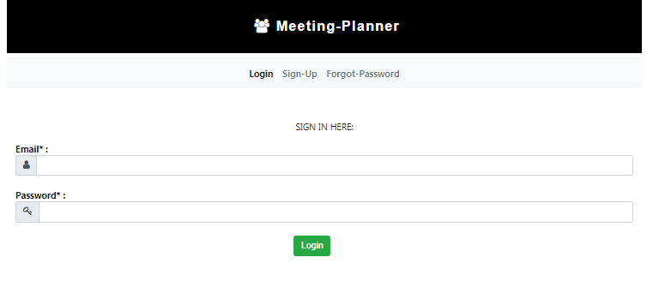

**2: Sign-up Page:**

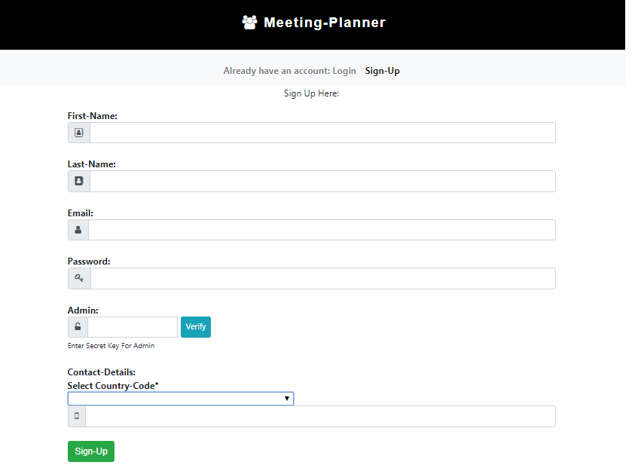

* Here in sign-up page user can create an account to Login to the system.
* If u wants to be an admin please enter secret key **“edwisor”** and click on Verify button to set admin as true.
* If u cannot click verify button then admin will be false.

**3: Forgot Password:**

* Enter Your Email address to recover password.

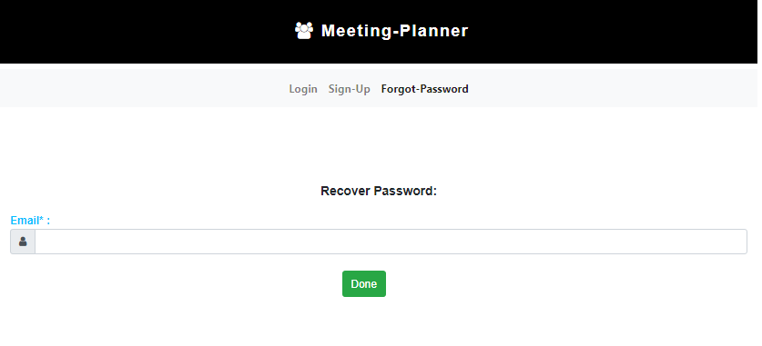

**4: Normal View**

* In normal view users able to see meetings.

**4.1: If No meeting**

* Users will not be able to edit or add meetings.
* If there is no meeting then “No Meeting” will be displayed.

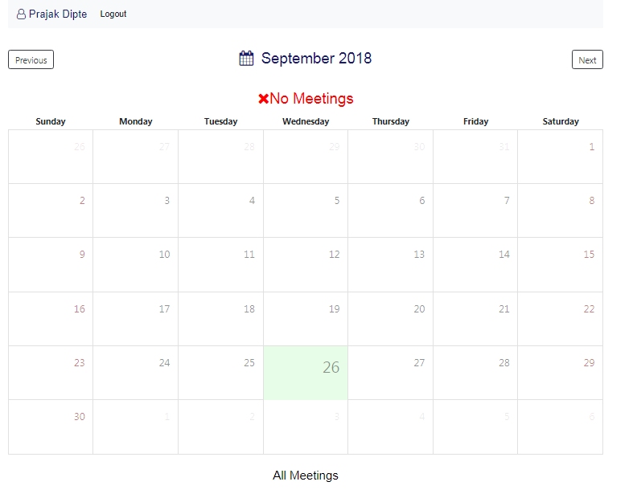

**4.2: If Meeting**

* If there is a meeting user shows a blue dot on the day on which meeting is scheduled.

Details of the meetings will be displayed in all meetings section.

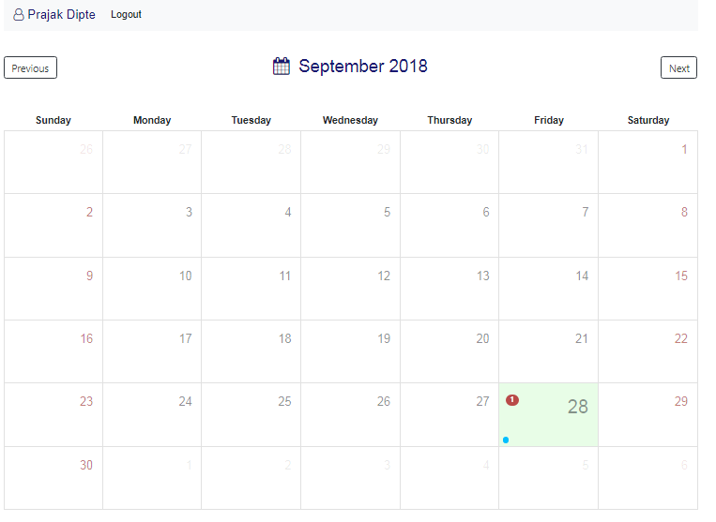

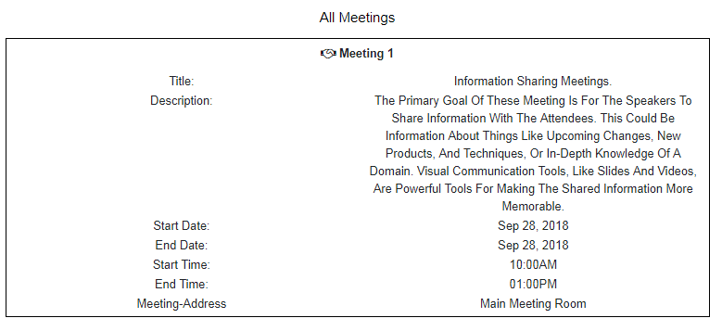

**5. Admin View**

* In the admin view, the admin will see all the list of users.
* It shows details of all the list of users shows in the database.
* Click on view button for scheduling a meeting of those users.
* After clicking on view button, the calendar view will get open of those users.

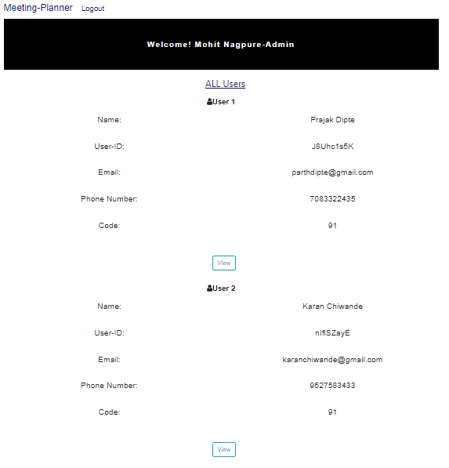

**5.1. If no meetings:**

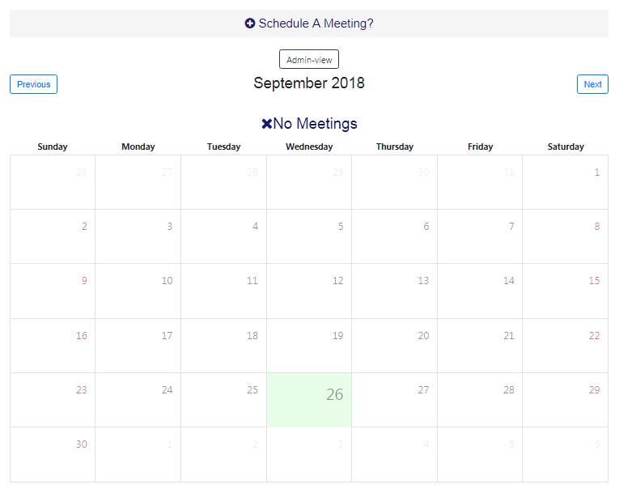

* The above calendar shows a view of a particular user.
* To add meeting click on **“Schedule a meeting”** at the top.
* Add view will appear on a in new page.

**5.2. Add View:**

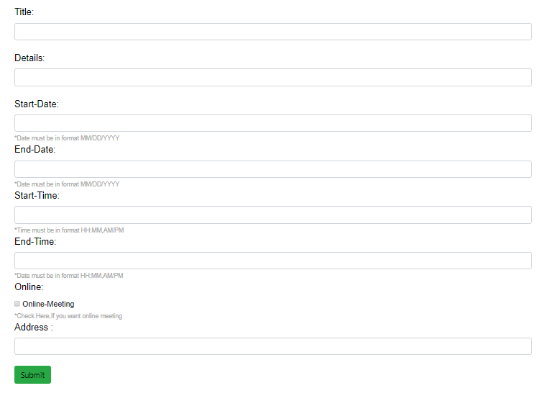

* In add view, admin can add meeting of the particular user.
* Click on submit button admin can add the meetings.

**5.3 If Meeting is present**

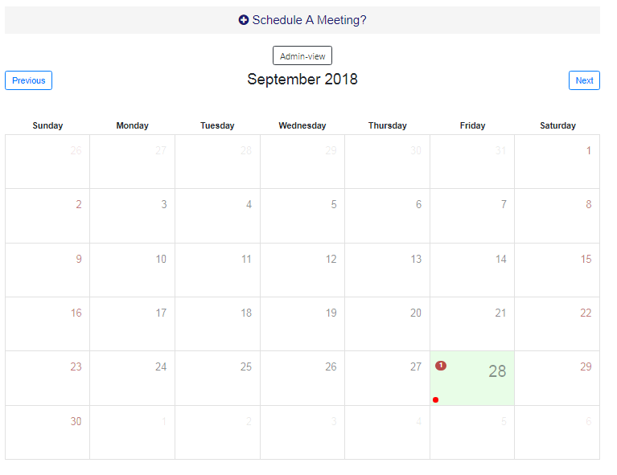

* If there will be a meeting then the red dot will appear on the date.
* To see the details about click on the date it will open a view on the different page.
* **Meeting View-1:**
* If you click on a date with no red dot then the following view will be shown:

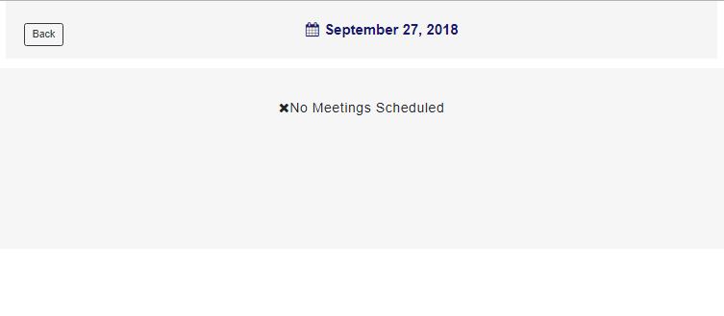

* Click on back button it will get back to calendar view:
* **Meeting View-2**
* If the cell with the red dot is clicked then this view will appear:

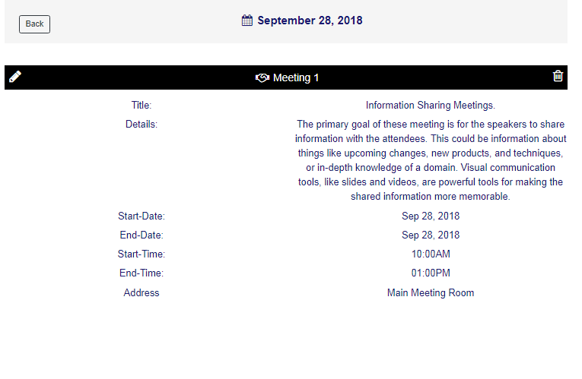

* The view has three feature

1. Back button: On Clicking back button you will get back to calendar view
2. Delete Icon: on clicking delete icon meeting will be deleted.
3. Edit Icon: On clicking edit icon, Edit view appears in new viewers.

* **Edit View:**

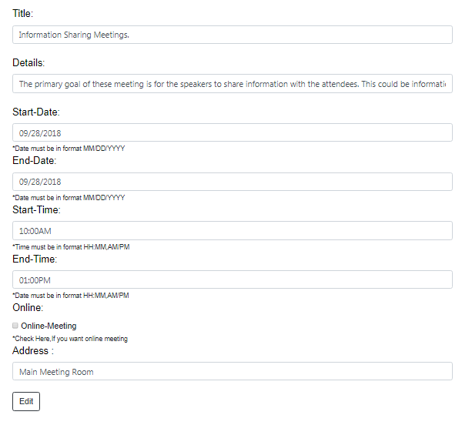

* The edit view open with previous details, admin can change the details to add an click on the edit button